实验七 曲线曲面
一、实验目的
- 了解多项式参数曲线的表示方法和特点
- 了解三次Hermite曲线生成算法，理解起点、终点切矢量对于曲线形状的控制作用；了解Bezier曲线生成算法，理解控制顶点对于曲线形状的控制作用；理解Bezier曲线与Hermite曲线的转换关系；了解三次B样条曲线生成算法，理解分段多项式参数曲线的定义方法；理解三次Bezier曲线与三次B样条曲线的转换关系。
二、实验内容
1.【必做】通过鼠标交互绘制一段三次Bezier曲线及其控制多边形。
#include <GLFW/glfw3.h>
#include <iostream>
#include <vector>

std::vector<std::pair<double, double>> controlPoints;

void mouse_button_callback(GLFWwindow* window, int button, int action, int mods) {
if (button == GLFW_MOUSE_BUTTON_LEFT && action == GLFW_PRESS) {
double xpos, ypos;
glfwGetCursorPos(window, &xpos, &ypos);
controlPoints.emplace_back(xpos, ypos);
}
}

void drawBezierCurve() {
glColor3f(1.0f, 0.0f, 0.0f);
glBegin(GL_LINE_STRIP);

for (float t = 0; t <= 1; t += 0.01) {
float x = 0;
float y = 0;

for (int i = 0; i < controlPoints.size(); ++i) {
float binomialCoefficient = 1;
for (int j = 0; j < controlPoints.size(); ++j) {
if (j != i) {
binomialCoefficient *= (t - float(j)) / (i - j);
}
}

x += binomialCoefficient * controlPoints[i].first;
y += binomialCoefficient * controlPoints[i].second;
}

glVertex2f(x, y);
}

glEnd();
}

void drawControlPolygon() {
glColor3f(0.0f, 0.0f, 1.0f);
glBegin(GL_LINE_STRIP);

for (const auto& point : controlPoints) {
glVertex2f(point.first, point.second);
}

glEnd();
}

int main() {
if (!glfwInit()) {
std::cerr << "Failed to initialize GLFW\n";
return -1;
}

GLFWwindow* window = glfwCreateWindow(800, 600, "Bezier Curve", nullptr, nullptr);
if (!window) {
std::cerr << "Failed to create GLFW window\n";
glfwTerminate();
return -1;
}

glfwMakeContextCurrent(window);
glfwSetMouseButtonCallback(window, mouse_button_callback);

glMatrixMode(GL_PROJECTION);
glLoadIdentity();
glOrtho(0, 800, 600, 0, -1, 1); // 使用 glOrtho 替代 gluOrtho2D

while (!glfwWindowShouldClose(window)) {
glClear(GL_COLOR_BUFFER_BIT);

if (controlPoints.size() >= 4) {
drawControlPolygon();
drawBezierCurve();
}

glfwSwapBuffers(window);
glfwPollEvents();
}

glfwTerminate();
return 0;
}
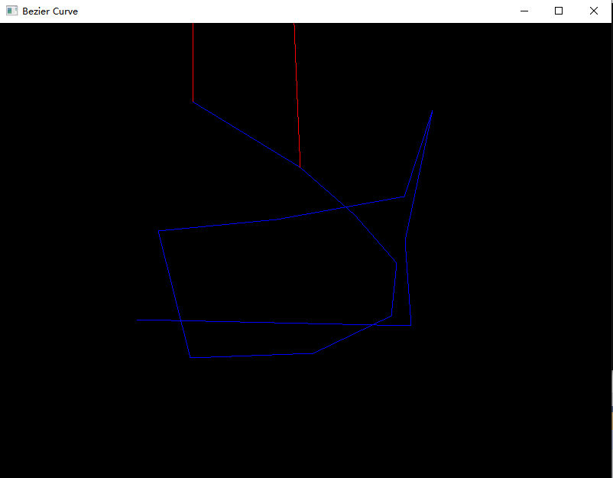
具体结果请参加附件的bazier.mp4
- 【必做】通过鼠标交互绘制连续多段三次B样条曲线。
#include <GLFW/glfw3.h>
#include <iostream>
#include <vector>

std::vector<std::pair<double, double>> controlPoints;
std::vector<std::vector<std::pair<double, double>>> splineSegments;

void mouse_button_callback(GLFWwindow* window, int button, int action, int mods) {
if (button == GLFW_MOUSE_BUTTON_LEFT) {
if (action == GLFW_PRESS) {
double xpos, ypos;
glfwGetCursorPos(window, &xpos, &ypos);
controlPoints.emplace_back(xpos, ypos);
}
else if (action == GLFW_RELEASE && controlPoints.size() >= 4) {
// Assuming each spline segment needs at least 4 control points
splineSegments.push_back(controlPoints);
controlPoints.clear();
}
}
}

void drawBSplineCurve(const std::vector<std::pair<double, double>>& points) {
glColor3f(1.0f, 0.0f, 0.0f);
glBegin(GL_LINE_STRIP);

for (size_t i = 3; i < points.size(); i += 3) {
for (float t = 0.0f; t <= 1.0f; t += 0.01f) {
float x = 0.0f;
float y = 0.0f;

for (int j = 0; j < 4; ++j) {
float blend = 1.0f;
for (int k = 0; k < 4; ++k) {
if (k != j) {
blend *= (t - float(i - 3 + k)) / (float(j - k));
}
}

x += blend * points[i - 3 + j].first;
y += blend * points[i - 3 + j].second;
}

glVertex2f(x, y);
}
}

glEnd();
}

int main() {
if (!glfwInit()) {
std::cerr << "Failed to initialize GLFW\n";
return -1;
}

GLFWwindow* window = glfwCreateWindow(800, 600, "B-Spline Curve", nullptr, nullptr);
if (!window) {
std::cerr << "Failed to create GLFW window\n";
glfwTerminate();
return -1;
}

glfwMakeContextCurrent(window);
glfwSetMouseButtonCallback(window, mouse_button_callback);

glMatrixMode(GL_PROJECTION);
glLoadIdentity();
glOrtho(0, 800, 600, 0, -1, 1);

while (!glfwWindowShouldClose(window)) {
glClear(GL_COLOR_BUFFER_BIT);

for (const auto& segment : splineSegments) {
if (segment.size() >= 4) {
drawBSplineCurve(segment);
}
}

if (controlPoints.size() >= 4) {
drawBSplineCurve(controlPoints);
}

glfwSwapBuffers(window);
glfwPollEvents();
}

glfwTerminate();
return 0;
}

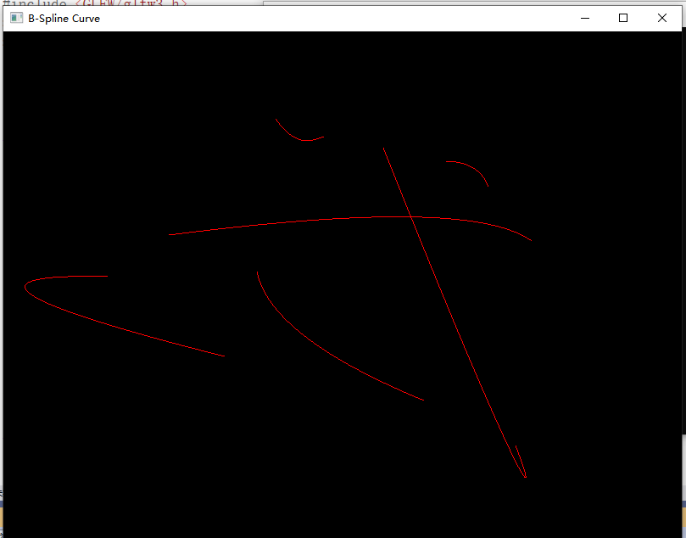
3.【选做】绘制几条完全重合的、心形三次多项式参数曲线（由两条对称曲线构成）：
（1）按下键盘‘1’时显示红色Hermite曲线（包括其端点切矢量）
（2）按下键盘‘2’时显示蓝色Bezier曲线（包括其控制多边形）
（3）按下键盘‘3’时显示绿色B样条曲线
4.【选做】题目3中曲线绘制完成后，实现曲线的交互修改，即通过鼠标捕捉控制点后拖动鼠标改变控制点位置。
三、实验参考
1.注册鼠标回调函数（当鼠标某一个button处于state状态时，鼠标回调函数被调用）
void glutMouseFunc(void (*func)(int button,int state,int x,int y));
其中自定义鼠标事件回调函数的定义方式类似于
void mouse(int button,int state,int x,int y)
{
if(button== GLUT_LEFT_BUTTON){…}
else{ …}
}
x,y:鼠标按下时光标相对于窗口左上角的位置，以像素为单位。屏幕像素坐标系原点位于窗口左上角，x轴正向向右，y轴正向向下。
button为鼠标的按键，取值可以为以下常量
GLUT_LEFT_BUTTON | 鼠标左键
GLUT_MIDDLE_BUTTON | 鼠标中键
GLUT_RIGHT_BUTTON | 鼠标右键
state为鼠标按键动作，取值可以为以下常量
GLUT_UP | 鼠标释放
GLUT_DOWN | 鼠标按下

2.注册鼠标移动回调函数glutMotionFunc。当鼠标在窗口中按下并移动时调用glutMotionFunc注册的回调函数。
void glutMotionFunc(void (*func)(int x, int y));
x,y:鼠标光标相对于窗口左上角的当前位置，以像素为单位

